Name: Date:
Class: ECS
DO NOW
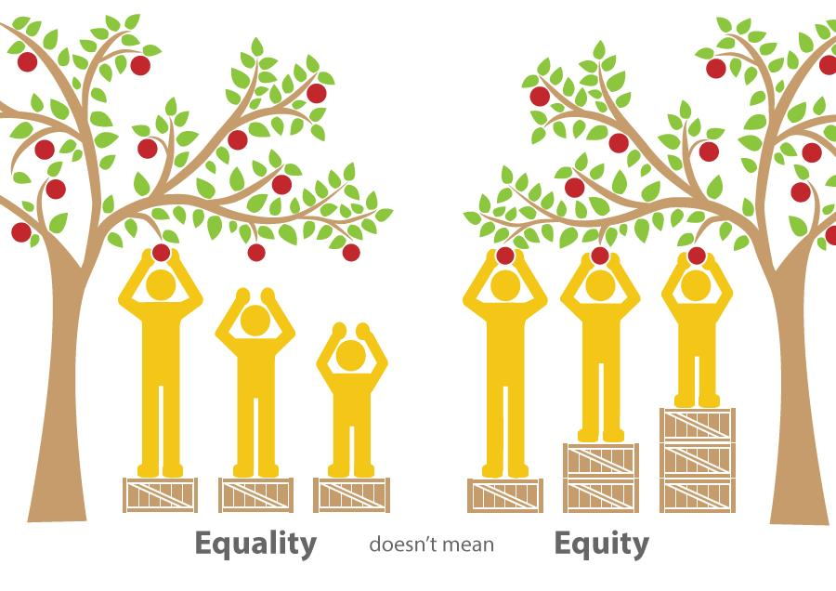

1. Do you agree or disagree with the above statement? _______________________
2. Why or why not? ______________________________________________
____________________________________________________________
____________________________________________________________
____________________________________________________________
3. How would you rephrase the statement?
____________________________________________________________
EXIT
Would you rather live in a society based on equality or equity? Explain why or why not. ________________________________________________________________________________________________________________________________________________________________________________________________________________________________________________

