Name: Date:
Class: ECS

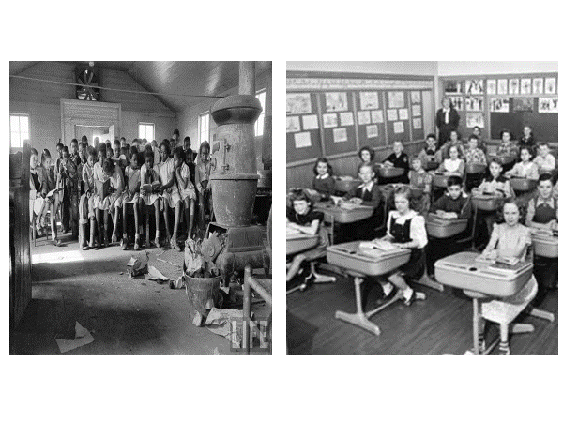
HOMEWORK
Directions: Use the image to answer the questions that follow

1. Which classroom would you want to be in and why? ________________________________________________________________________________________________________________________
2. How do the pictures support the ‘separate but equal’ law? ________________________________________________________________________________________________________________________
3. How do the pictures support the statement, ‘equality doesn’t mean equity?’ ____________________________________________________________________________________________________________________________________________________________________________________
4. Can separate treatment be equal treatment? Explain or give an example ____________________________________________________________________________________________________________________________________________________________________________________

